Flagstaff Hill R-7 School Classroom Music/Dance Overview Term 2 2017
Mrs Robyn Videon (Mon – Thurs)

*10 week term *Week 7 - Monday holiday, Tuesday Student Free Day
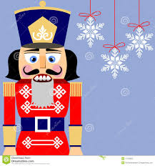
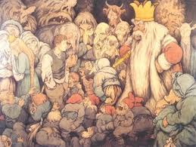
All Reception to Year 7 classes have 1X50min lesson per week.
R – 4: Focus on Dance for assessment, some Music too.
5 – 7: Focus on Music for assessment, some Dance too.
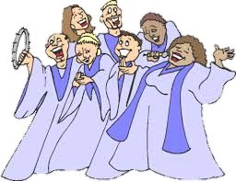
Main content
….with inspirational ballet music from the classics
Rec – 2: DANCE
Yr 3 & 4: DANCE

Yr 5 & 6: MUSIC Gospel Voices (Music Room 6)
Yr 7: MUSIC Notable Classics – Molto Allegro, In the Hall of the Mountain King

Additional content:
Recorder– Yr 2 – 4: Revision and extension, integrated into most lessons. (Recorder will be introduced to Yr 1s in Semester 2)
Festival Choir is a Special Interest program offered to selected Yr 5, 6 & 7 students through Terms 1, 2 & 3. From time to time, choir members will have differentiated activities in Classroom Music lessons.
Years R to 2 DANCE
• ELEMENTS OF DANCE:
Space – levels, directions, shapes, dimension, personal/general, pathways
Time – tempo, rhythm
Dynamics – control energy, moving to illustrate different environments, heavy/light sharp/soft movements
Relationships - groupings, spatial relationships, interaction, use of simple props e.g. hoop, Group Loop
• SKILLS:
Locomotor – walking, running, marching, galloping, skipping, crawling, rolling
Non-locomotor – bending, stretching, twisting, turning, growing, melting to the ground
• SAFE DANCE PRACTICES:
Showing care, respect and responsibility for other students in the dance space.
Awareness of the boundaries of the dance space.
Awareness of own body’s needs. E.g. getting a drink after dance activities for hydration.

Years 3 and 4 DANCE
• ELEMENTS OF DANCE:
Space, Time, Dynamics, Relationships – as for R-2, but with increasing refinement and variety e.g. positive/negative space, stillness, over/under, near/far, lead/follow, meet/part
• SKILLS:
Locomotor – adding and combining more complex movements
Non-locomotor – adding rising, pulling, swinging, spinning, twisting, collapsing, curling
• SAFE DANCE PRACTICES:
Include warming up and cooling down
• CHOREOGRAPHIC DEVICES:
Contrast
Repetition
• Responding:
Describe and discuss similarities and differences between dances.
• Making:
Use the elements of dance to represent a story or mood.

Years 5, 6 & 7 MUSIC
• ELEMENTS OF MUSIC
Rhythm – , and time signatures, bars and barlines. Semibreve , minim , crotchet , quaver , and rests, semiquaver , compound metre
Pitch – pentatonic and major scales, recognising an arpeggio or riff; treble and bass cleff
Dynamics and expression – smoothly (legato), detached (staccato), accent
Form – theme/motif, phrase, rondo (ABACA), riff, ostinato
Timbre – acoustic, electronic sounds; voice and instrument types
Texture – contrast within layers of sound
• SKILLS (INCLUDING AURAL SKILLS)
Identify and notate metre and rhythms
Singing and playing in parts
Recognising instrumental and vocal timbres and digitally generated sounds
Holding and playing instruments and using voices safely and correctly
Listening to others controlling volume and tone in ensemble activities

